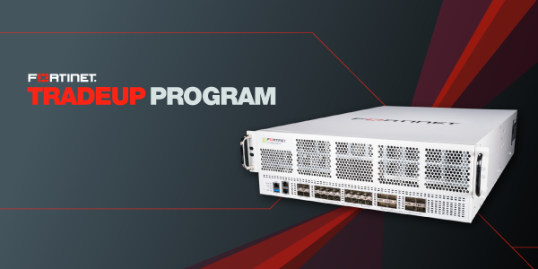
Dear [customer]:
Our records indicate that you own a [Fortinet product] that has been designated as “end-of-order” and is eligible for a trade up discount.
By taking advantage of Fortinet’s TradeUp Program, you gain access to the latest Fortinet solutions with improved performance, updated security, and an advanced feature set, all while benefiting from the program’s cost savings – up to 54% off hardware and 34% on services.
Please contact us to discuss the options available for your trade up, including the transfer of your existing services contract to a new device. We’ll evaluate your current needs as well as your plans for growth to ensure the perfect fit for your business goals.
LEARN MORE

